Name
Professor
Course
School
Rock Mechanics- Assignment 2
Question 1
Considering a BX core specimen, the least diameter will be taken as 42 mm. Given is the length of the sample as 80 mm with a mass of 250 g, and a specific gravity of 2.65.
a) The volume of the specimen will be found as;
$$V=\left(\frac{pi*D^{2}}{4}\right)*l=\left(\frac{3.142*{42}^{2}}{4}\right)*80=0.11 m²$$
$$ρdry=\frac{Mass of solids }{volume }=\frac{250 kg*1000}{0.11*1000}=2270 kg/m³$$
b) Void ratio (e) was calculated as follows;
$$ρdry=\left(\frac{Gs}{1+e }\right)* ρwater$$
Substituting for e we find;
$$e=\left(\frac{Gs*ρwater}{ρdry }\right)-1= \left(\frac{2.65*1000}{2270 }\right)-1= 0.167=16.7\%$$
c) Porosity (n) was evaluated as follows;
$$n= \frac{e}{1+e}= \frac{0.167}{1+0.167}=0.143=14.3\%$$
d) Water content (w) was calculated as follows that, from the known formula; when fully saturated, the degree of saturation is 100%, hence:
$$W=\frac{Sr*e}{Gs}=\frac{1*0.143}{2.65}*100=5.39\%$$
Question 2
- Mass of sample (dry) + drum = 902 g (sandstone)- A;
- Mass of sample (dry) + drum = 928 g (dolomite)- A;
- Mass of empty drum = 432 g (sandstone)- B;
- Mass of empty drum = 434 g (dolomite)- B;
- Mass of sample (dry) + drum after 1st weathering cycle = 871 g (sandstone)- C;
- Mass of sample (dry) + drum after 1st weathering cycle = 926 g (dolomite)- C;
- Mass of sample (dry) + drum after 2nd weathering cycle = 821 g (sandstone)- D;
- Mass of sample (dry) + drum after 2nd weathering cycle = 921 g (dolomite)- D.
Sandstone 1st weathering cycle
$$Durability index=\frac{C-B}{A-B}x 100=\left(\frac{871-432}{902-432}x 100\right\}=93.4\%$$
Dolomite 1st weathering cycle
$$Durability index=\frac{C-B}{A-B}x 100=\left(\frac{926-434}{928-434}x 100\right\}=99.6\%$$
Sandstone 2nd weathering cycle
$$Durability index=\frac{D-B}{A-B}x 100=\left(\frac{821-432}{902-432}x 100\right\}=82.8\%$$
Dolomite 2nd weathering cycle
$$Durability index=\frac{D-B}{A-B}x 100=\left(\frac{921-434}{928-434}x 100\right\}=98.6\%$$
Sandstone can be categorized as a highly durable rock with dolomite as a flat durable rock. Sandstone is less porous and has no grains.
Question 3
Take pi as 3.142.
I_{s} = P/De² where P is the failure load in Newton and De is the equivalent diameter, which D for the diametral tests in mm, and similar to 4A/pi for block, axial, and lump tests. The definition of A is equal to WD, which is the minimum cross-section area of the plane through the plate contact points.
I_{s(50)} = I_{s} * (De/50)^{0.45}
I_{a(50)} = I_{s(50)} measured perpendicular/I_{s(50)} measured parallel
Test | W1 | W2 | D | P | De² | Is | De | Is(50)
 | mm | mm | mm | kN | mm² | MPa | mm | MPa
1 | 53.90 | 53.87 | 25.23 | 2.14 | 1730.29 | 1.24 | 41.60 | 1.14
2 | 53.73 | 53.65 | 25.00 | 2.29 | 1707.51 | 1.34 | 41.32 | 1.23
3 | 54.12 | 54.01 | 25.07 | 2.44 | 1723.78 | 1.42 | 41.52 | 1.30
4 | 53.72 | 53.86 | 25.06 | 2.75 | 1713.84 | 1.60 | 41.40 | 1.47
5 | 53.89 | 53.92 | 25.04 | 1.84 | 1717.89 | 1.07 | 41.45 | 0.98
6 |  |  | 54.13 | 3.41 | 2930.06 | 1.16 | 54.13 | 1.21
7 |  |  | 53.86 | 2.85 | 2900.90 | 0.98 | 53.86 | 1.02
8 |  |  | 53.77 | 3.12 | 2891.21 | 1.08 | 53.77 | 1.12
9 |  |  | 54.05 | 3.02 | 2921.40 | 1.03 | 54.05 | 1.07
10 |  |  | 53.38 | 3.18 | 2849.42 | 1.12 | 53.38 | 1.15
11 | 63.42 | 63.57 | 45.28 | 5.11 | 3655.83 | 1.40 | 60.46 | 1.52
12 | 63.45 | 63.34 | 30.15 | 2.87 | 2431.19 | 1.18 | 49.31 | 1.17
13 | 63.68 | 63.81 | 30.38 | 3.68 | 2462.89 | 1.49 | 49.63 | 1.49
14 | 63.43 | 63.38 | 29.83 | 2.54 | 2406.91 | 1.06 | 49.06 | 1.05
15 | 63.59 | 63.47 | 31.25 | 3.41 | 2525.06 | 1.35 | 50.25 | 1.35
16 | 37.14 | 28.89 | 18.98 | 1.52 | 698.07 | 2.18 | 26.42 | 1.63
17 | 55.13 | 29.58 | 27.22 | 2.19 | 1025.04 | 2.14 | 32.02 | 1.75
18 | 29.89 | 37.14 | 17.63 | 1.93 | 670.86 | 2.88 | 25.90 | 2.14
19 | 45.69 | 39.61 | 24.59 | 2.31 | 1239.99 | 1.86 | 35.21 | 1.59
20 | 19.89 | 33.26 | 14.36 | 1.24 | 363.62 | 3.41 | 19.07 | 2.21
 |  |  |  |  |  | Mean Perpendicular |  | 1.18
 |  |  |  |  |  | Mean Parallel |  | 1.63
 |  |  |  |  |  | Ia(50) |  | 0.72
 |  |  |  |  |  | UCS |  | 28.25

Question 4
Area = 60 mm x 60 mm
a) From the graph below, the peak shear strength on the rock is 0.13 N/mm², with a residual shear strength of 0.12 N/mm².
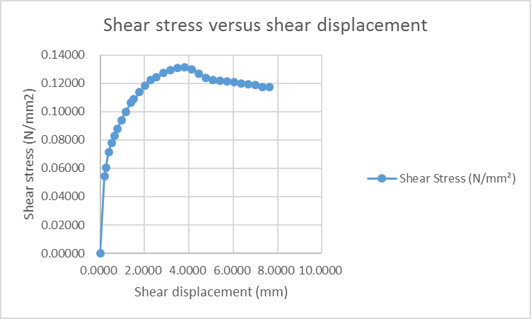
b) From the below graph, during shear, the volume of the rock sample changes up to a certain level when it stabilized. The volume reduced volume with an increase in volume and then stopped allowing an increase in the normal displacement.
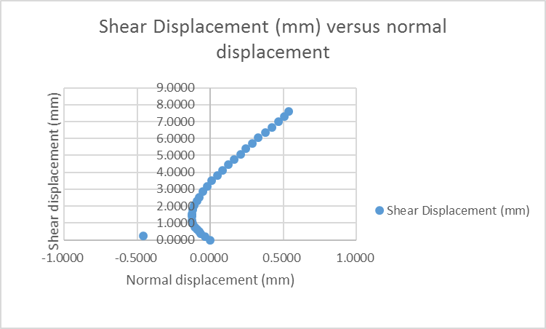
c) The normal load applied to the sample is 660 N, and the area of the sample is 60 mm by 60 mm. The peak and residual angles of friction are at perpendicular to the y-axis, as shown in the graph below.
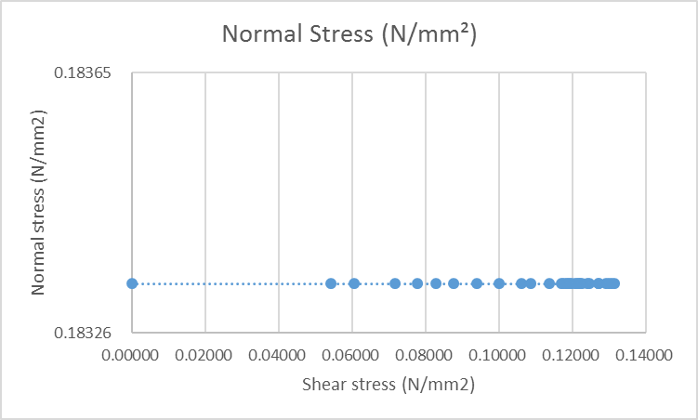
Question 5
Given is that the diameter is 59 mm, and the confining stress was 25 MPa. From the graph, the a) peak triaxial compression strength is 87 MPa, and b) the residual triaxial compression strength was at half the peak value, 43.5 MPa, as illustrated in the figure below. c) and d) the slopes at the residual strength gives the tangent Young’s modulus and tangent Poisson’s ratio. The Young’s was calculated as follows:
E = change in stress/change in strain
= 82/0.4
= 205 MPa, lateral
= (60-25)/(3-3.2)
= 43.75 MPa, axial
For Poisson’s ratio,
v = lateral strain/axial strain
= 0.3/3.8
= 0.079
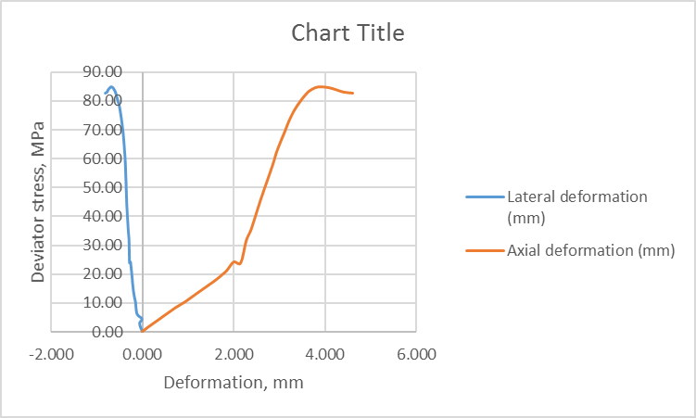
Other calculations have been shown in the attached Excel Spreadsheet.

